**ANALYSIS OF INTERACTIVE DASBOARD OF SUPERSTORE USING EXCEL**

**Description.**

* Using timeline to display the order and shipment date
* Using slicer to dropdown regions of sales, category and subcategory of product
* Calculate sum of sales by month
* Calculate sum of sales by region
* Calculate sum of sale by Category
* Calculate sum of discount and profit
* Calculate sum of sales by states, present top 10 states with the highest sale, top 5 with the most discount and top 5 with the less profit.
* Determine sale, profit and discount by subcategory.
* Create and link 3 dashboard together.

1. Using timeline to display the order and shipment date

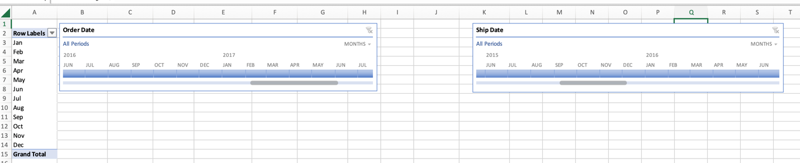

2)Using slicer to dropdown regions of sales, category and subcategory of product

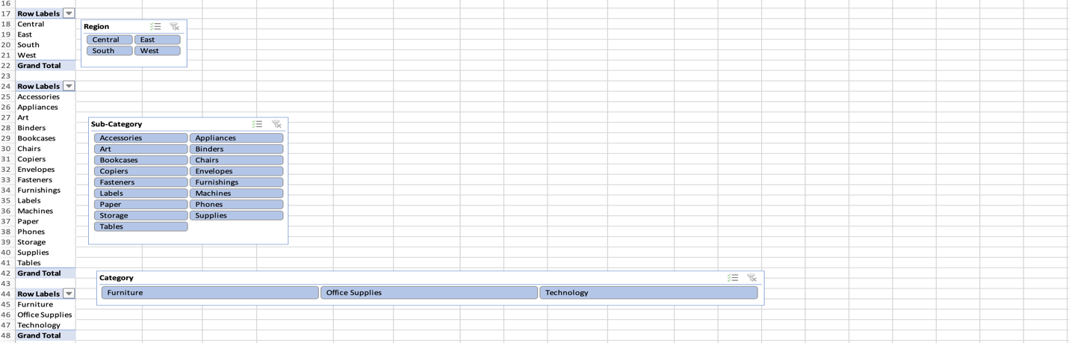

3) Calculate sum of sales by month

4) Calculate sum of sales by region



5) Calculate sum of sale, discount and profit by Category

6) Calculate sum of sales by states, present top 10 states with the highest sale, top 5 with the most discount and top 5 with the less profit.

1. Determine sale, profit and discount by subcategory.

1. Create and link 3 dashboard together.

